**Name: VIJAY VISHNU P B**

**Roll No: 49**

**Batch: B**

**Date: 21/04/2022**

**NETWORKING & SYSTEM ADMINISTRATION LAB**

**Experiment No.: 3**

**Aim**

Familiarization of the linux commands.

**Procedure**

**42. read**

This command is used to read the content of a line to a variable.

Syntax :- $ read <variable_name>

$ echo $variable_name

Output :-

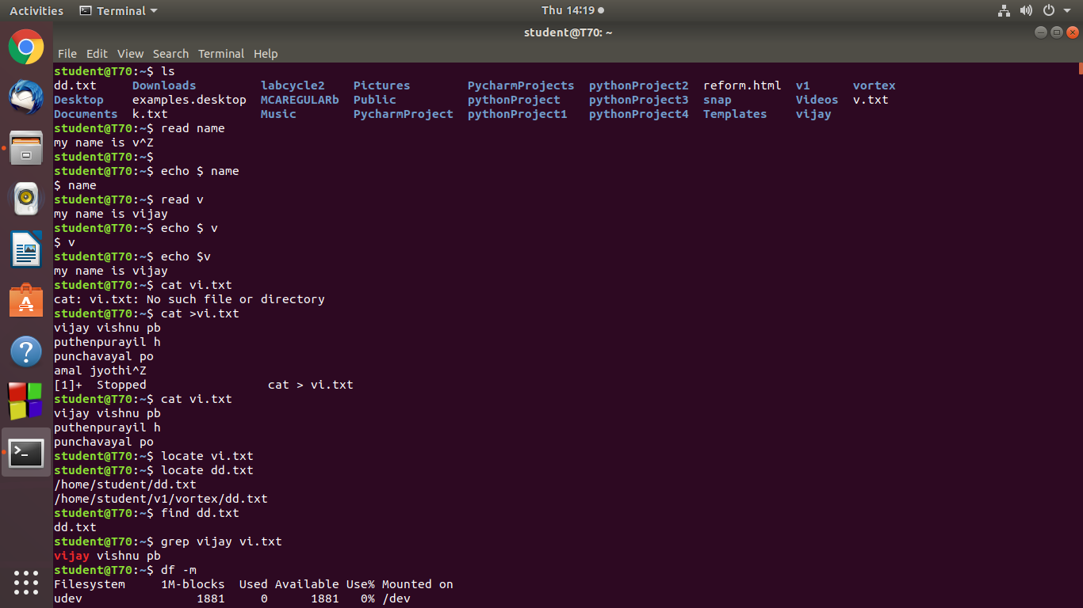

**43. locate**

This command is used to locate a particular file from any directory.

Syntax :- $ locate filename.txt

Output :-



**44. find**

This command is used to locate a particular file from current directory.

Syntax :- $ find filename.txt

Output :-



**45. grep**

This command is used to search a file for a particular pattern of characters, and displays all lines that contain that pattern.

Syntax :- $ grep <word> <filename.txt>

Output :-



**46. df**

This command is used to get a report on system disk space usage.

Syntax :- $ df

Output:-

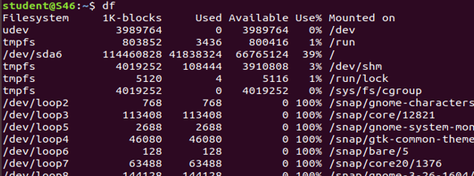

**47. df -m**

This command is used to see the reports in megabytes.

Syntax :- $ df -m

Output :-

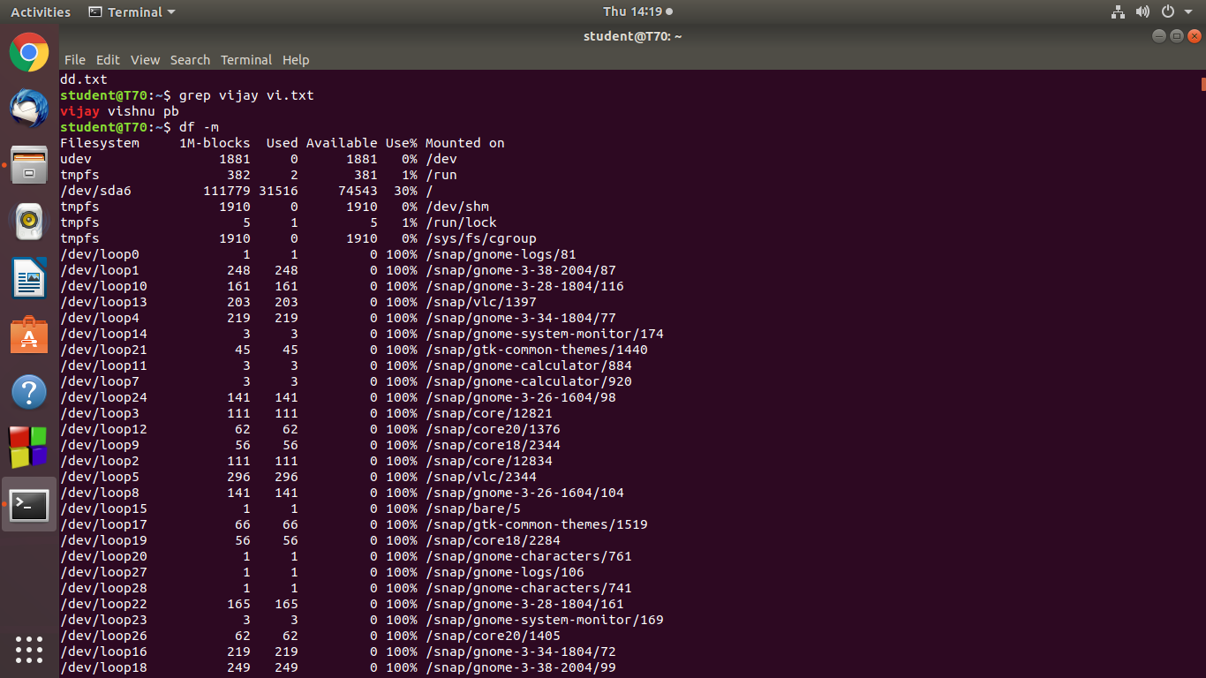

**48. du**

This command is used to check how much space a file or directory takes.

Syntax :- $ du

Output :-

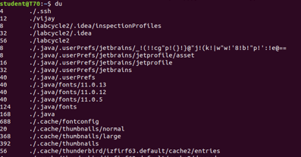

**49. wc -l**

This command is used to count the number of lines from a file.

Syntax :- $ wc -l <filename.txt>

Output :-

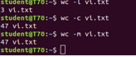

**50. wc -w**

This command is used to count the number of words from a file.

Syntax :- $ wc -w <filename.txt>

Output :-



**51. wc -c**

This command is used to count the number of characters from a file.

Syntax :- $ wc -c <filename.txt>

Output :-



**52. wc -m**

This command is used to count the number of bytes from a file.

Syntax :- $ wc -m <filename.txt>

Output :-



**53. grep -i**

This command is used for a case insensitive search and display.

Syntax :- $ grep -i <word> <filename.txt>

Output :-



**54. grep -v**

This command is used for an inverted search and display.

Syntax :- $ grep -v <word> <filename.txt>

Output :-

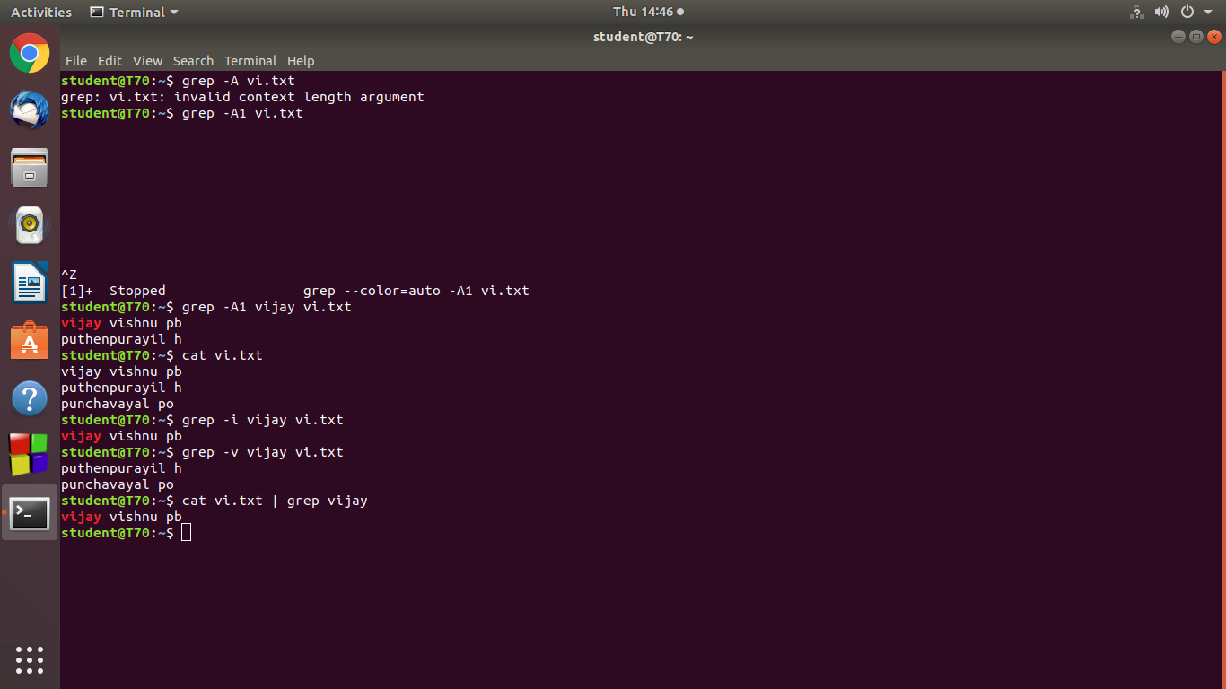

**55. cat file | grep**

This command is used for a case insensitive search.

Syntax :- $ cat <filename.txt> | grep <word>

Output :-



**56. grep -A1**

This command is used to display the line after the word.

Syntax :- $ grep -A1 <word> <filename.txt>

Output :-



**57. grep -B1**

This command is used to display the line before the word.

Syntax :- $ grep -B1 <word> <filename.txt>

Output :-



**58. grep -C1**

This command is used to display the line before and after the word.

Syntax :- $ grep -C1 <word> <filename.txt>

Output :-

